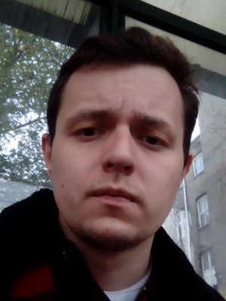**Hlushko Ihor**

**Unity3d Developer**

**Personal information:**

**Address:** Zaporizhia, Ukraine.

**Date of birth:**  25th August 1993 (27)

**Contacks:**

**Mobile number:** +380955631492

**Skype/E-mail:** [Crozen93@gmail.com](mailto:Crozen93@gmail.com)

[LinkedIn](https://www.linkedin.com/in/ihor-hlushko-crozen93/)

**Nationality:**  Ukrainian.

**About me:**

I have 2 years experience in gaming and mobile application.

I write about Unity3d, games development, editor tools,

build & content pipelines and other stuff.

**Work experience:**

**Company**: CMS Games LLC

Junior Unity3d Developer - (from 10.2016 to 02.2018) (1 year 4 months)

During the work of the company, the main tasks were: development of 2D and 3D applications from scratch. Refinement and maintenance of existing code, work with textures and animations.

I developed an application from scratch that was uploaded to [iOS](https://apps.apple.com/us/app/samurai-swords-store/id1321910145) and [Android](https://play.google.com/store/apps/details?id=com.cms.SamuraiSword&hl=ru) markets. Also the application has a pc and macos version and version WebGl.

**Education:**

**Zaporizhzhya Institute of Economics and Information Technologies (ZIEIT)**

Master in Software engineering (Summa Cum Laude). From 09.2015 to 01.2019 (3 years 4 months)

### **Zaporizhzhya National Technical University (ZNTU)**

Master in Micro- and nanoelectronics. From 09.2012 to 05.2016 (3 years 8 months)

**Skills:**

**Languages:** Ukrainian, Russian – native; English – A2 (Pre-Intermediate).

**Programming Language:** OOP(C#);

**Cross-platform development:** Windows, MacOs, WebGl, iOs, Android;

**Unity skills**:

* Experience with scripting, GUI styles, textures, game optimization,
* Experience development unity client/server application;
* Experience using Google Analytics for Unity;
* VR(Google Cardboard);
* AR(Vuforia),
* Local data storage (CSV)